**Addressing Table**

|  |  |  |  |  |
| --- | --- | --- | --- | --- |
| **Device** | **Interface** | **Address** | **Subnet Mask** | **Default Gateway** |
| RTA | G0/0 | 10.10.10.1 | 255.255.255.0 | N/A |
|  | G0/1 | 10.10.20.1 | 255.255.255.0 | N/A |
| SW1 | VLAN1 | 10.10.10.2 | 255.255.255.0 | **10.10.10.1** |
| SW2 | VLAN1 | 10.10.20.2 | 255.255.255.0 | **10.10.20.1** |
| PC-1 | NIC | **10.10.10.24** | 255.255.255.0 | **10.10.10.1** |
| PC-2 | NIC | **10.10.20.35** | 255.255.255.0 | **10.10.20.1** |

**Part 1**

* **Step 1**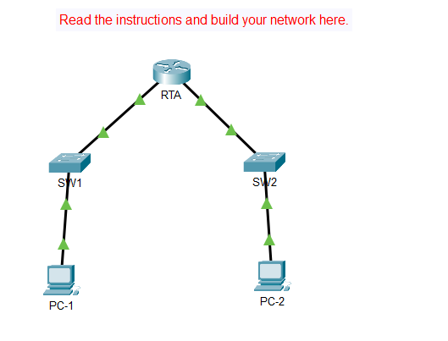

**Part 2**

* **Step 1**

**a,** 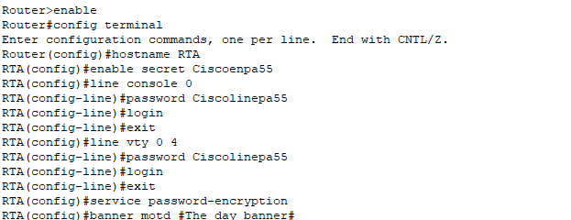

**b,** 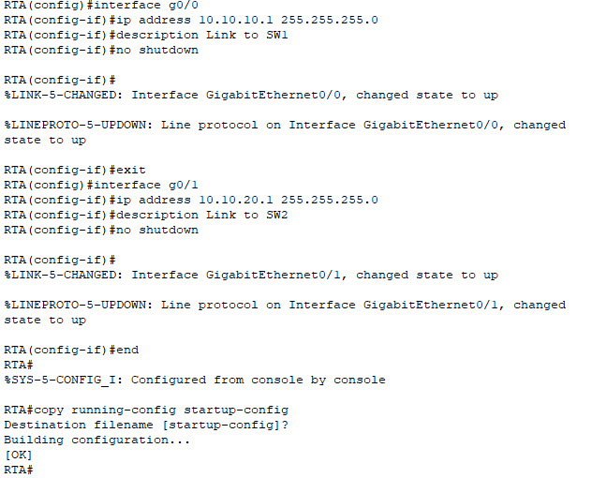

* **Step 2**

**SW1**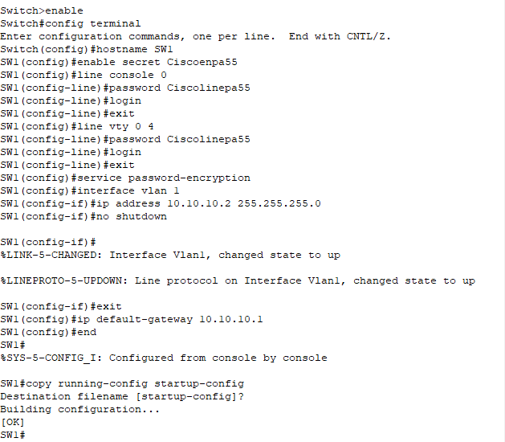

**SW2**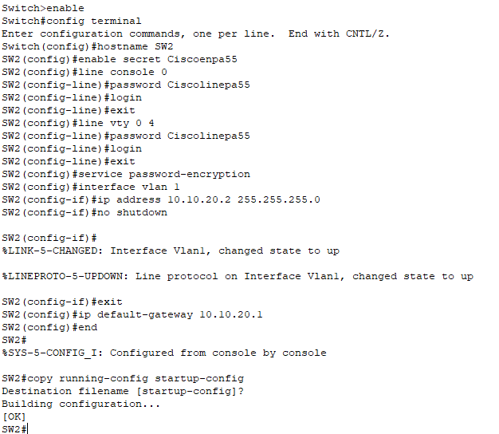

* **Step 3**

**PC-1**

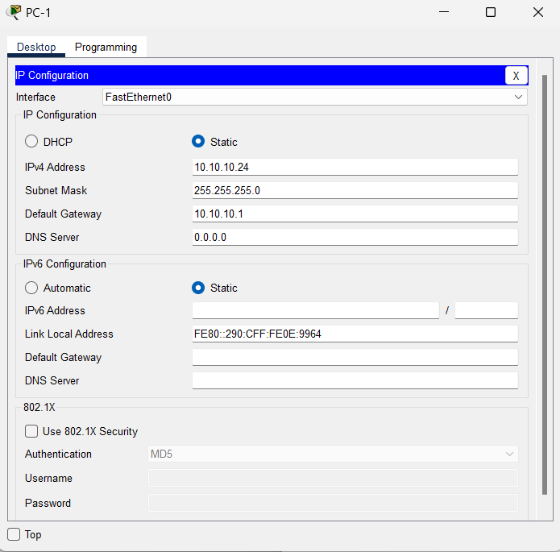

**PC-2**

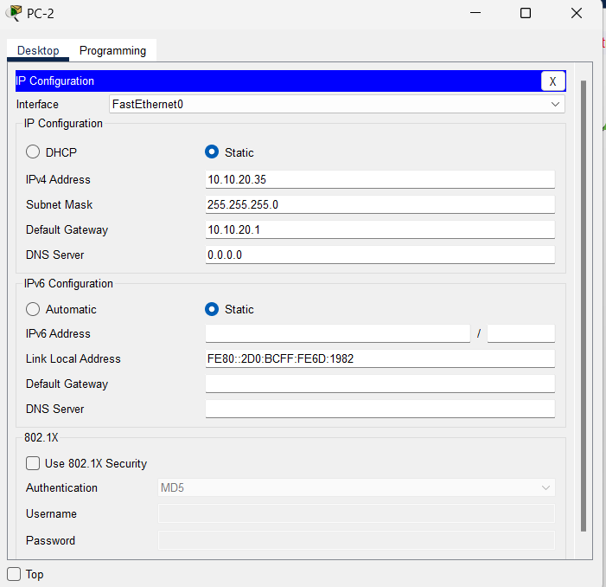

* **Ping PC-1 to SW1**

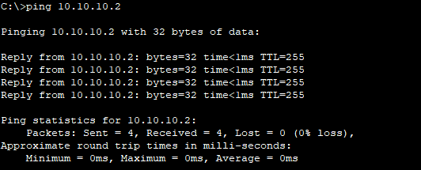

* **Ping PC-1 to RTA**

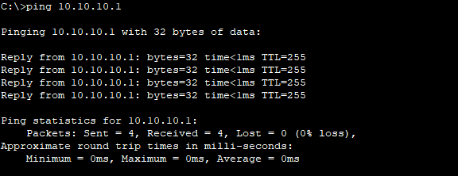

* **Ping PC-1 to SW2**

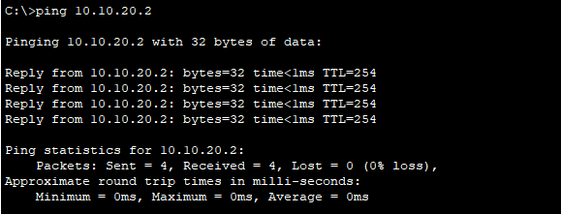

* **Ping PC-1 to PC-2**

